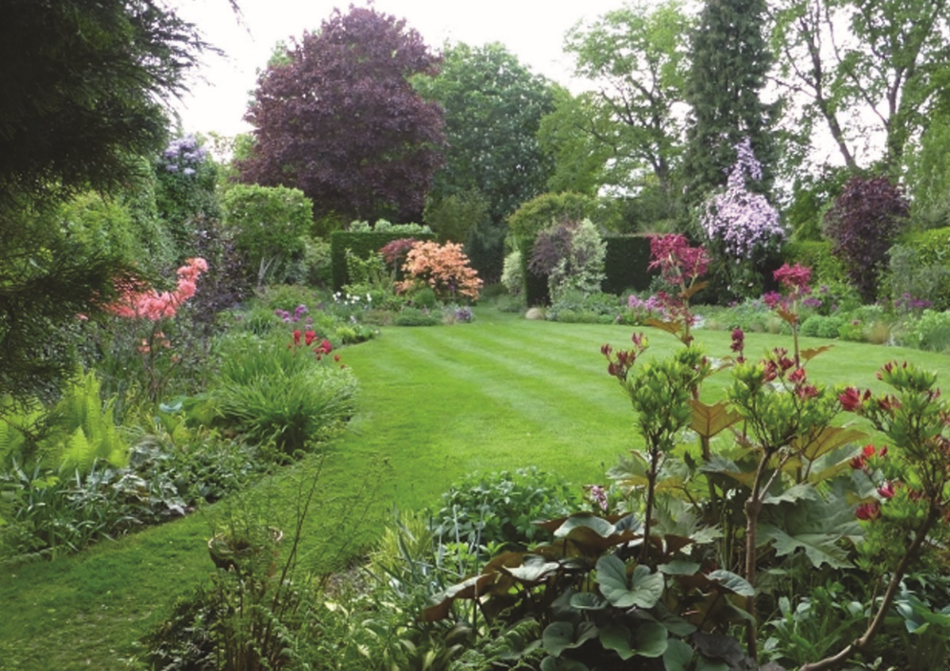

# Please use NGS regular for main title

Please use Georgia for the rest of the text. To change the photo, please click on the image and click Picture tools > format > Change picture.