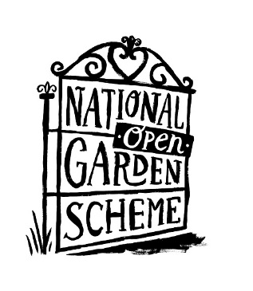
Aligning your Emails with the new Brand: Creating a Signature

Contents
- The template
- How to create your email signature:
  - Using Outlook
  - Using Webmail
  - Using Yahoo
  - Using Gmail
  - Using Iphone
  - Using Mac Mail

1. The Template
Your email signature incorporating the new brand should be set up following the example template below.
You should use the font Georgia and the signature should include your name, volunteer role, county, telephone number and links to your county’s National Garden Scheme social media pages.
Note: You can copy and paste the signature from this document and amend in your signature box

[Your Name]
[Your Volunteer Role]

National Garden Scheme, [insert your county]
Tel: [Your contact number]
Website: ngs.org.uk
Follow us on: Facebook | Twitter | Instagram (add in your county’s links here)

You can also add the email banner image shown above (download here) with a hyperlink to the ngs.org.uk website. If your email platform does not allow you to add a banner image then please add a hyperlink to the ngs.og.uk text in your signature.

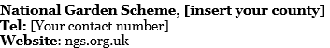

If you have any problems then please do not hesitate to contact us on hello@ngs.org.uk
- How to create your email signature…
- Using Outlook
Step 1: Log in to your Outlook account and create a new email message.
Step 2: On the Message tab, in the Include group, choose Signature > Signatures.
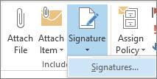
Step 3: Under Select signature to edit, choose New, and in the New Signature dialog box, type a name for the signature.
Step 4: Under Choose default signature, set the following options for your signature:
- In the E-mail account list, choose an email account to associate with the signature.
- In the New messages list, select your new brand signature that you want to be added automatically to all new email messages.
- In the Replies/forwards list, select your new brand signature that you want to be added automatically (auto sign) when you reply to or forward messages.

Step 5: Under Edit signature, type the signature and add the National Garden Scheme email banner graphic by selecting the insert image button and paste the image underneath the text.
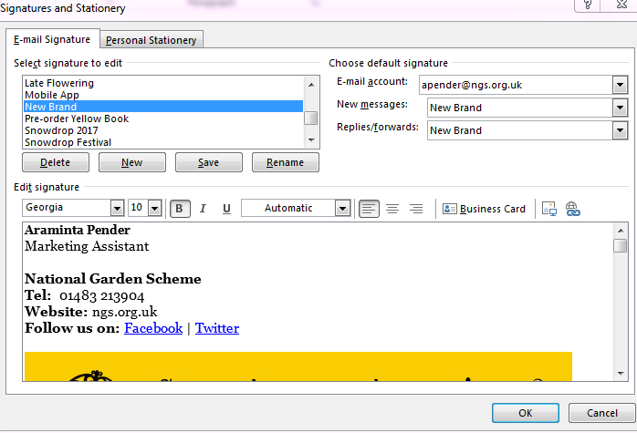
Step 6: To add hyperlinks to your National Garden Scheme social media channels, simply highlight the text, select the hyperlink button and in the address box, type the web address of your social media channel,
e.g. https://www.facebook.com/ngsgardens
Note: To add a hyperlink to the banner graphic, simply select the image and as before, click the hyperlink button and in the address box type the ngs.org.uk web address. To add a hyperlink to the ngs.org.uk text, simply highlight the text, select the hyperlink button and in the address box, type the ngs.org.uk web address.
Step 7: Once finished, select OK.
Step 8: Test your signature by sending yourself an email. It should automatically appear at the bottom of each new message.

- Using Webmail
Step 1: Login to Outlook Web App.

Step 2: On the nav bar, select Outlook (or Mail) or select the App launcher icon (top left corner) > Outlook.

Step 3: On the nav bar, choose the Settings cog > Options.

Step 4: Under Options, choose Settings > Mail or under Options, choose MAIL > Layout > Email signature.

Step 5: Under Email signature, compose your custom signature in the available text box following the brand guidelines explained at the beginning of this document, including the email banner graphic and hyperlinks.

Step 6: If you want your signature to display at the bottom of all outgoing items, including replies and forwards, select Automatically include my signature on messages I send. Or you can manually add your signature to any message. To do this compose a new message and at the top of the message, select Insert > Signature (or Your signature).

Step 7: Select the Save button.

Step 8: Test your signature by sending yourself an email. Click the Signature drop down menu and select the signature you'd like to use.

- Using Yahoo
Step 1: Log into your Yahoo! email account.

Step 2: Click the Settings cog in the top right hand corner of the screen and select Settings from the dropdown menu.

Step 3: Select Accounts from the list of options and then click on your Yahoo email address from under Email Addresses.

Step 4: In the Signature box, check the box next to ‘Append a signature to the emails you send’. Then in the empty text box compose your custom signature following the brand guidelines explained at the beginning of this document including the email banner graphic and hyperlinks.

Step 5: Select the Save button.

Step 5: Test your signature by sending yourself an email. It should automatically appear at the bottom of each new message.

- Using Gmail
Step 1: Login to your Gmail account.

Step 2: In the top right, click the Settings cog and select Settings from the menu.

Step 3: In the Signature section, add your signature text in the box following the brand guidelines explained at the beginning of this document including the email banner graphic and hyperlinks. Click the Insert Image icon to insert your banner graphic.

Step 4: At the bottom of the page, click Save Changes.

Step 5: Test your signature by sending yourself an email. It should automatically appear at the bottom of each new message.

- Using an Iphone
Step 1: Select Settings from your Home screen.

Step 2: Select Mail or Mail, Contacts, Calendars depending on what your phone displays.

Step 3: Under the Mail section scroll down and select Signature.

Step 4: Select Per Account. This will reveal the different email accounts set up on your phone.

Step 5: Select the email account that you wish to add your new signature to.

Step 6: Delete any existing text and compose your custom signature following the brand guidelines explained at the beginning of this document.

Step 7: Once you have finished typing, select Mail to return to the previous screen. Your new signature will automatically save and appear at the bottom of all outgoing email.

Step 8: Test your signature by sending yourself an email. It should automatically appear at the bottom of each new message.

- Using Mac Mail
Step 1: Choose Mail, then Preferences and select Signatures.

Step 2: In the left column, select the email account you want to use the signature for, then click +.

Step 3: In the middle column, type a name for the signature.

Note: The name appears in the Signature pop-up menu in the message header when you write a message.

Step 4: In the right column (the preview), create your signature following the brand guidelines explained at the beginning of this document including the email banner graphic and hyperlinks.

Note: You can use the Edit or Format menus in Mail to change the font or layout, turn text into links, or check spelling. To add an image, drag the file into the preview.

If you want your signature to appear after the original text of messages you reply to or forward, deselect the “Place signature above quoted text” checkbox.

Step 5: Test your signature by sending yourself an email. It should automatically appear at the bottom of each new message.

