Creating an email signature in Outlook in office 365

When in outlook click on the settings cog in the top right hand corner.

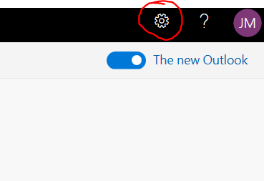

Click on view all outlook settings in the bottom right hand corner

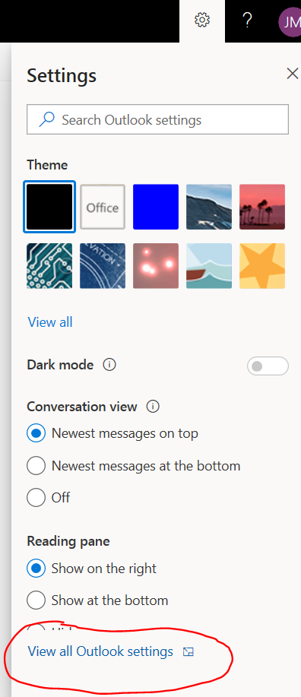

Click on compose and reply

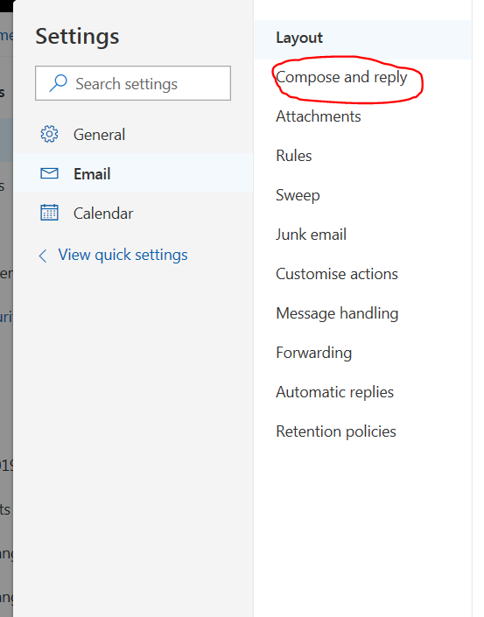

You should now see a box where you can add your email signature. You can add images by clicking on the picture icon and you can also change the font etc.

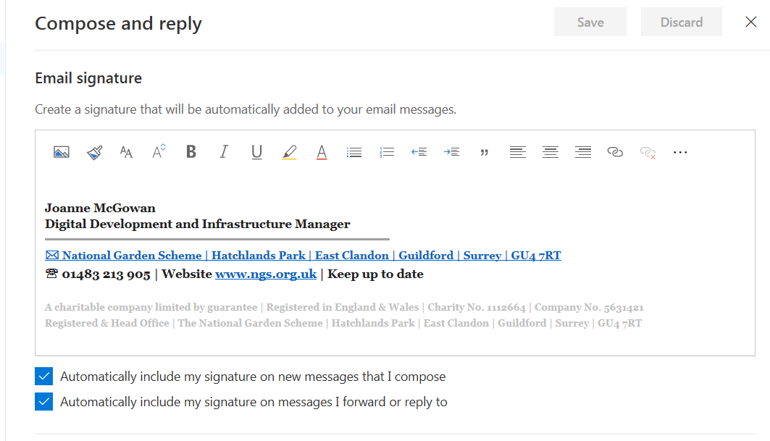

Don’t forget to click save at the end. It can sometimes take a while for the signature to pull through after you have saved.