GDPR and Cyber Security Guidelines for Treasurers
As a treasurer it is likely that you could receive scam or “phishing” emails from scammers trying to extract money unlawfully from our organisation. To help you spot and deal with this appropriately please follow these guidelines
- If you receive an email asking you to transfer money or provide financial information, whether it seems legitimate or not, please phone the person who you think the email is from with the contact phone number you have for them. If you do not have a phone no for them contact head office. Do not reply to the email or attempt to transfer funds.
- Three Common ways Scammers get in contact
  - They send an email that looks like it come from someone you know but it actually from a suspicious email address Please see image below. This is a real email that looks like it was coming from someone within the NGS, but on closer inspection you can see it is from a suspicious email address. It looks very genuine but it was not sent from George Plumptre our CEO but from a scammer.
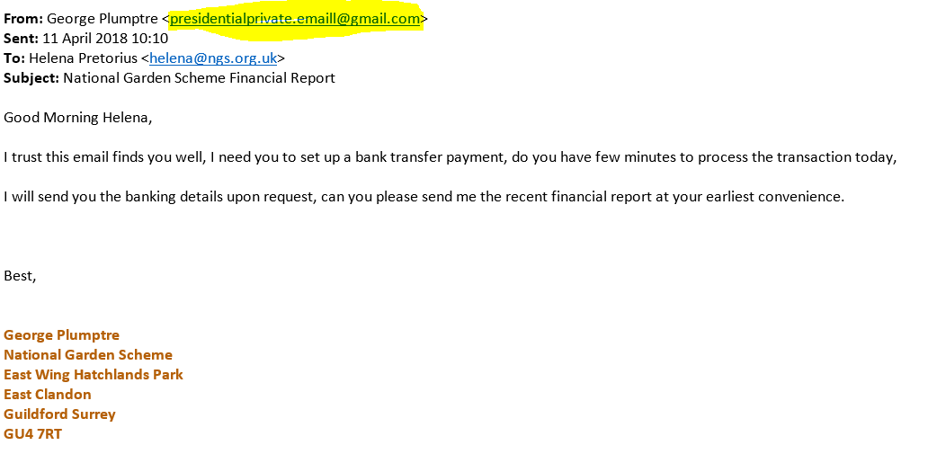
  - However, scammers are getting more sophisticated and can produce email addresses that look very genuine and that include names, so if they are asking for money or for financial information about our organisation, double check first.
  - It is also possible that a hacker could gain access to a legitimate NGS account and send out spurious requests, so in all cases if you are requested to transfer money or share financial information PHONE FIRST AND DOUBLE CHECK

- Please from now on, as an added safeguard, can you always use your ngs.org.uk email address for National Garden Scheme business. If you do not have one set up contact head office who can arrange this for you. We can offer more protection to you from scammers if you do this including deleting and blocking known scam email addresses.
- If you do not currently have an ngs.org.uk email address or are at any time unsure, forward any suspicious emails to either joanne@ngs.org.uk or helena@ngs.org.uk and we can advise.
- If you are sending emails out to groups of people please always blind copy the recipients (bcc).
Please, do not worry about offending anyone or seeming silly for double checking. Scammers are getting more clever in their tactics and it is better to be safe than sorry.

