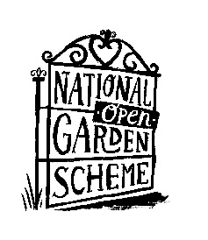

Win a signed Gardening Book!

**We have 3 signed copies of Gardeners World to give away. Simply complete your details below and put in the competition box for a chance to win.**

Name ____________________________________________

Email Address ______________________________________

[ ] Tick here if you would like to receive information on our garden openings and events in the future

County (Optional – but so we can send you details of garden openings close to you) _________________________

We will never share your details with any other organisations and will only use your data for the purposes specified above. Please visit our website to view our full privacy policy at [www.ngs.org.uk](http://www.ngs.org.uk)

*Please place this form in the box provided or hand to the garden owner/NGS representative*