|  |  |
| --- | --- |
|  | Tick here if you would like to receive details in the future about National Garden Scheme openings and events |

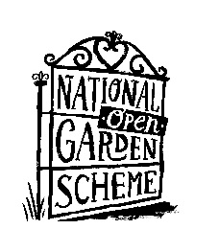We’d love to keep in touch and let you know about our wonderful garden openings and events. Simply fill out your details below and we’ll keep you informed.

Name ______________________ Email Address __________________________________________

County (Optional – but so we can send you details of garden openings close to you) ___________

We will never share your details with any other organisations and will only use your data for the purposes specified above. Please visit our website to view our full privacy policy at [www.ngs.org.uk](http://www.ngs.org.uk)

*Please tear off this slip and place in the box provided. Thank you*

--------------------------------------------------------------------------------------------------------------------------------------

|  |  |
| --- | --- |
|  | Tick here if you would like to receive details in the future about National Garden Scheme openings and events |

We’d love to keep in touch and let you know about our wonderful garden openings and events. Simply fill out your details below and we’ll keep you informed.

Name ______________________ Email Address __________________________________________

County (Optional – but so we can send you details of garden openings close to you) ___________

We will never share your details with any other organisations and will only use your data for the purposes specified above. Please visit our website to view our full privacy policy at [www.ngs.org.uk](http://www.ngs.org.uk)

*Please tear off this slip and place in the box provided. Thank you*

--------------------------------------------------------------------------------------------------------------------------------------

|  |  |
| --- | --- |
|  | Tick here if you would like to receive details in the future about National Garden Scheme openings and events |

We’d love to keep in touch and let you know about our wonderful garden openings and events. Simply fill out your details below and we’ll keep you informed.

Name ______________________ Email Address __________________________________________

County (Optional – but so we can send you details of garden openings close to you) ___________

We will never share your details with any other organisations and will only use your data for the purposes specified above. Please visit our website to view our full privacy policy at [www.ngs.org.uk](http://www.ngs.org.uk)

*Please tear off this slip and place in the box provided. Thank you*

--------------------------------------------------------------------------------------------------------------------------------------