**Saving garden images from the website**

On our new garden pages of the website we are trying to display garden images a bit better in a gallery. With this there are some minor adjustments you may need to make when saving images particularly on mobile devices.

**Saving garden images on mobile devices**

1. Click on view gallery

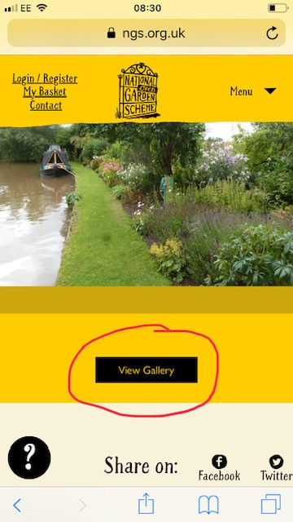

1. When the image pops up you can use the arrow in the bottom right corner to scroll through
2. If you wish to save the image click/hold your finger on the top part of the image (not the bottom as it will think you are wanting to use the arrows.)
3. You will then get the option to save image.



**Saving gardens on desktop/PC**

1. Click on view gallery
2. Right click with your mouse on the image
3. A box will come up and one option will be save image as.

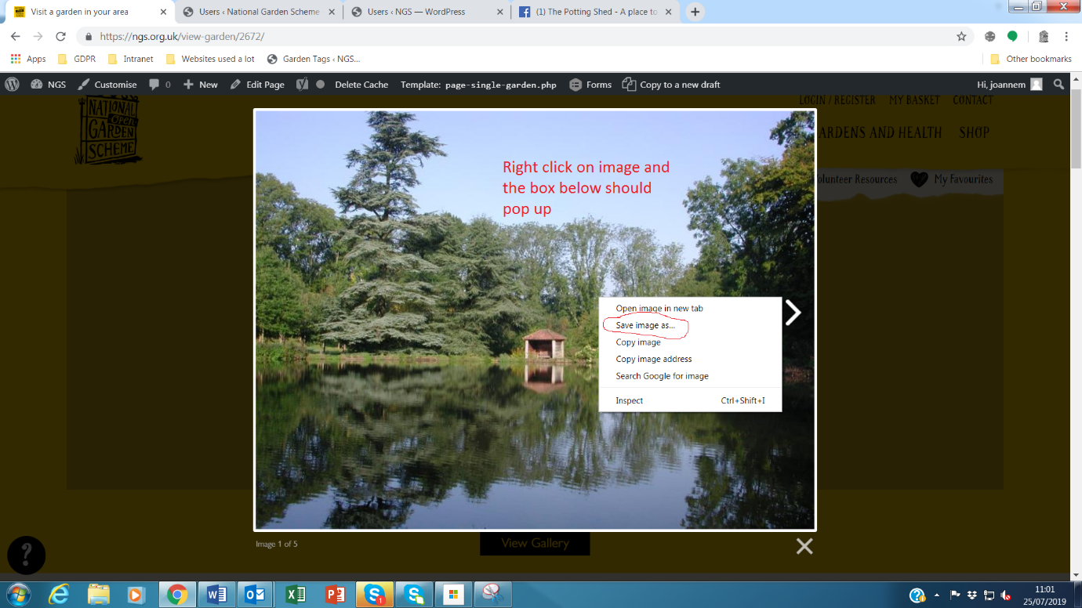

N.B. - Please always ensure that any devices you use have up to date software and operating systems installed. This will perform performance of all sites and helps keep your devices secure.