**Nourishing the Nation’s Soul since 1927**

Research conducted by the National Garden Scheme (NGS) reveals that visiting a private garden is good for the soul. Over 85% of NGS supporters report that being in a National Garden Scheme garden has a positive impact on their mental wellbeing and 8 out of 10 (80%) feel happier after visiting than before.

“Championing the health benefits of gardens has been at the heart of our ethos since our foundation in 1927 when we opened gardens to raise funds for community nursing,” explains National Garden Scheme CEO, George Plumptre.

“From the beneficiaries receiving funding from us today - such as the eleven Horatio’s Gardens at NHS Spinal Injury Centres across the country - to the garden owners who have found solace in the creation and sharing of their gardens, and the garden visitors who derive such pleasure from being in beautiful gardens, there can be little doubt that gardens and gardening form an important path to improved health and wellbeing.”

In 2016, the National Garden Scheme commissioned The King’s Fund to produce a report on the topic of Gardens and Health and began an annual funding programme to support gardens and health-related projects run by charities. A year later its Gardens and Health programme was launched to continue raising awareness of the amazing impact gardens and gardening can have on physical and mental health.

But it’s not just the National Garden Scheme that recognise the health benefits. Gardening is now one of the elements of social prescribing; an important component of the NHS comprehensive model of personalised care that aims to link an individual with an activity to improve their health and mental wellbeing. According to NHS England, 2.5 million people will benefit from social prescribing by 2024.

“Gardening ticks many boxes,” says Professor Sam Everington who leads the pioneering Bromley by Bow social prescribing movement in London. “Whether it’s a houseplant, a window box, an allotment or a back garden, gardening is accessible to all of us. It provides purpose, hope, routine and rewarding results. In a community context, like an allotment, therapy garden or even a garden at a GPs surgery, it also generates conversation helping to reduce isolation and create a deep sense of satisfaction and purpose.”

Professor Everington adds: “Inactivity and isolation are major causes of ill-health, not only can they reduce life expectancy by about ten years, but they also contribute to the growing pressure on GP and hospital services. Getting people motivated, setting them on a path to new activities and opportunities are vital for the improved health and wellbeing of thousands of people.”

The National Garden Scheme is fully supportive of social prescribing, especially in relation to introducing people to gardens and green spaces and the health benefits that brings. So much so that in 2020 announced a tripling of funding to community-based garden projects throughout England and Wales.

FINAL PARA FOR “LOCK DOWN” PERIOD  
As this rather unexpected gardening season warms up and the portfolio of beautiful National Garden Scheme gardens blooms behind locked gates it’s never been more important to find tranquillity and solace in a restful outside space. If you are unable to get out, don’t have a garden of your own or simply want to have your soul revived you can join a virtual garden tour on the National Garden Scheme website here: <https://ngs.org.uk/virtual-garden-tours/>

___________________________________________

For more information on the National Garden Scheme’s and its Gardens and Health programme visit: <https://ngs.org.uk/gardens-and-health/>

For more information about the National Garden Scheme in ADD YOUR COUNTY contact County Organiser, ADD YOUR CO CONTACT

____________________________________________

IMAGES:

Visiting an NGS garden helps change lives

Credit: Julie Skelton

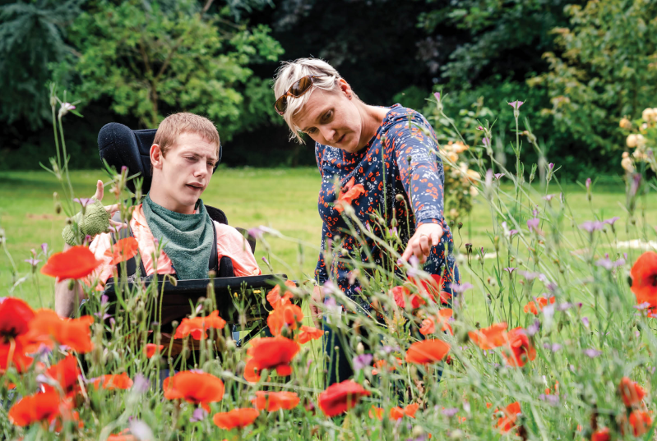

**Add a selection of your county images that fit these suggested caption:**

‘Gardening is good for your physical and mental wellbeing’

‘Stunning planting and inspiring views are good for the soul’

‘Gardens can be restful and restorative in a busy world’