Donations through Just Giving
Encouraging donations through JustGiving is a way of enabling potential visitors to support our garden owners who work so hard to prepare their gardens for an open day, whilst also raising funds despite increasing numbers of cancellations. You and your garden owners can share our National Garden Scheme JustGiving page with supporters: https://www.justgiving.com/ngs giving them the opportunity to make a donation and highlight the garden they are supporting.
Alternatively, you can set up your own county page by clicking on the Start Fundraising button. By doing this you can raise funds for the National Garden Scheme, and at the same time, maintain a record of how many donations have been made through your own interventions and send out your own automatic thankyou notes.
If you choose to create your own county page, please follow the steps below and use the proposed wording as a basis for your page to ensure a consistent message:

Setting up your own county fundraising page in aid of the National Garden Scheme
CREATE YOUR PAGE
- On the Just Giving website click on Start Fundraising

- You will be asked ‘What are you raising money for?’
Select A charity
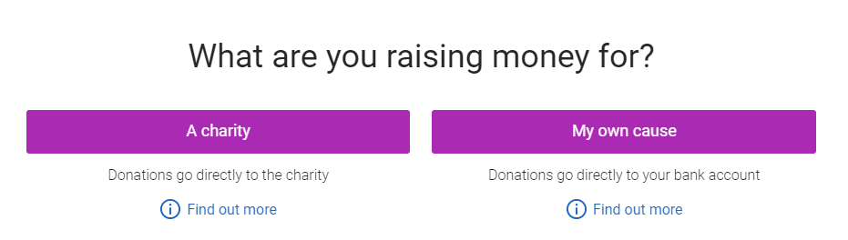
- You can then sign up for a Just Giving login using your ngs.org.uk email
- Search for the cause you want to support and click Select
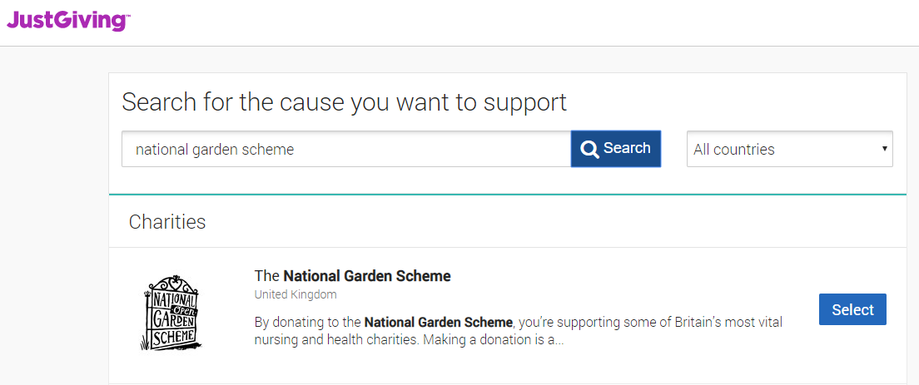
- Select taking part in an event and click on Organised Event
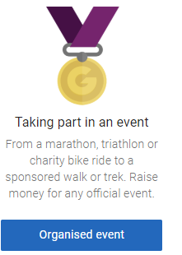
- Click on Add your own
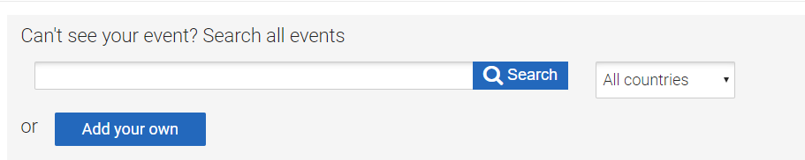
- Complete the relevant fields. Suggested fields include:
called*: Supporting our gardens in [county]
Web address: [county]NationalGardenScheme
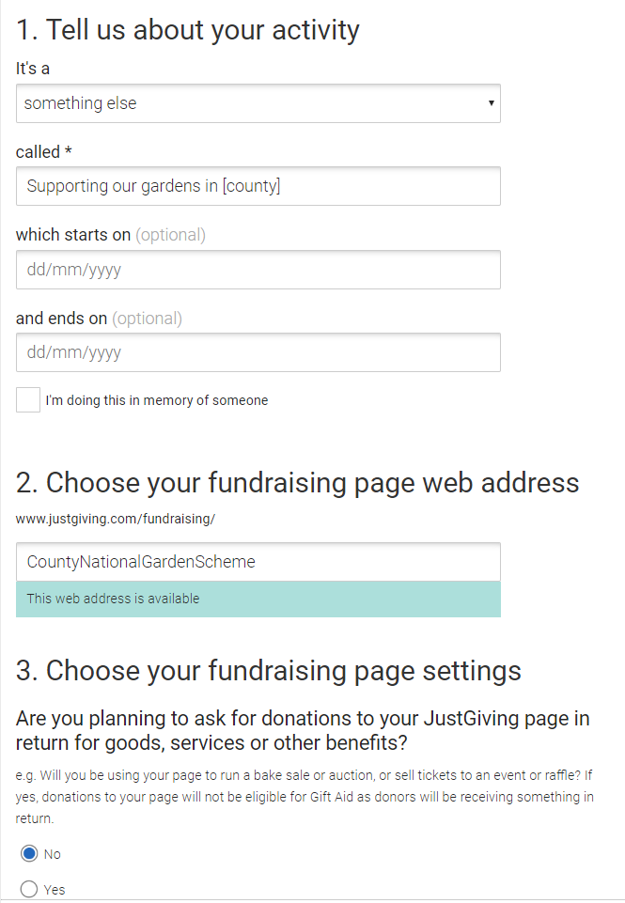

- Click SUBMIT to create your page

PERSONALISE YOUR PAGE
- Visit your Fundraising Page (www.justgiving.com/...), click 'Log in' in the top right and enter your log in details.
- Click 'Edit your page' in the top left.
- Scroll down to 'Edit and personalise your page'

Edit your title, target, summary and story

- Click on ‘Edit your page title, summary and story’ and enter the desired text in each of the relevant sections. Suggested text is given below:
Title: [County National Garden Scheme]
Summary: There are two sections to this: It starts with a question ‘Tell us what you are doing and why?’ (50 characters)
Suggested copy:
Many gardens cannot open so we are raising funds
The sentence then continues with ‘for the National Garden Scheme because’ (50 characters)
Suggested copy:
nursing and health charities rely on our donations.
Full sentence will show as: Many gardens cannot open so we are raising funds for the National Garden Scheme because nursing and health charities rely on our donations.
Your story’
Suggested copy:
It is so sad that many of our garden owners across [county], who have worked tirelessly to prepare their gardens so that they are looking their best for their open day, have been forced to cancel this year due to the Coronavirus pandemic. Making a donation through JustGiving is a wonderful way to show your support of our generous garden owners, as well as help us raise money for vital nursing and health charities.
If you do decide to make a donation in lieu of visiting a garden can we ask you to mention the garden/s you are particularly sorry not to have visited this year in your message.
Your donation will help us ensure that we are able to make donations to our beneficiaries including Macmillan, Marie Curie, Hospice UK, Carers Trust, The Queen’s Nursing Institute, Parkinson’s UK, Perennial and Horatio’s Garden in 2021.
For further information on how we distribute funds please visit ngs.org.uk
Thanks for taking the time to visit our JustGiving page.
- Click ‘Save and continue' to preview how it looks.
Add photos
- Click on ‘Add Photos’ in the edit area and then ‘Select photo’. Choose the photo from your device and add a caption (up to 40 characters). Press ‘Upload photo’ to finish.
You can add a photo of your choice, the logo, a garden or even a photo of your county booklet. This is a good way of connecting the page to the local gardens opening for the National Garden Scheme.

