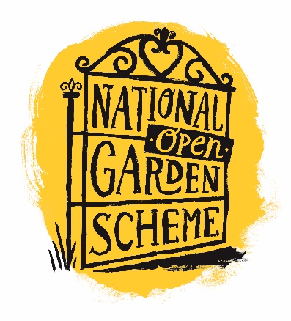**NEWS RELEASE**

Immediate release/embargoed until:

**TITLE** (Make the journalist want to read on!)

Paragraph 1: Summarise the story - who, what, where, when and why. All key information needs to be in this paragraph.

Paragraph 2: Put in more details to flesh out the story you have outlined in the first paragraph

Paragraph 3: “Quotes from you or someone relevant to the story.”

Paragraph 4: Extra relevant information, including call to action e.g.Visit ngs.org.uk to find your perfect garden.

Ends

For more information, high resolution images or to interview a spokesperson, please contact xxx by emailing xxxx or calling xxx.

**NOTES TO EDITOR**

**About National Garden Scheme**

The National Garden Scheme gives visitors unique access to over 3,500 exceptional private gardens in England and Wales, and raises impressive amounts of money for nursing and health charities through admissions, teas and cake.

Thanks to the generosity of garden owners, volunteers and visitors we have donated over £60 million to nursing and health charities, and made a donation of £2.88 million in 2020. Founded in 1927 to support district nurses, we are now the most significant charitable funder of nursing in the UK and our beneficiaries include Macmillan Cancer Support, Marie Curie, Hospice UK, The Queen’s Nursing Institute, Parkinson’s UK and Carers Trust.

The National Garden Scheme doesn’t just open beautiful gardens for charity – we are passionate about the physical and mental health benefits of gardens too. We fund projects which promote gardens and gardening as therapy, and in 2017, we launched our annual Gardens and Health Week to raise awareness of the topic.

To find your perfect garden, visit **ngs.org.uk**, download the National Garden Scheme app or purchase the National Garden Scheme’s *Garden Visitor’s Handbook*, which is published annually and available via **ngs.org.uk/shop** and at all good book retailers.