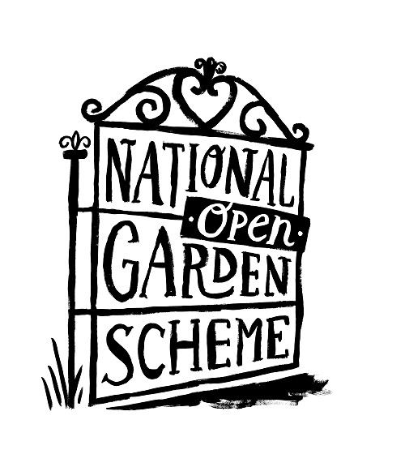**Press release**  
**March 31, 2021**

**25 years of garden giving**

**In 2021 the National Garden Scheme celebrates 25 years of support and over £20 million in funding for three of its key beneficiaries: Marie Curie, Hospice UK and Carers Trust.**

“Twenty-five years ago, in 1996 our donations went to support district nurses and Macmillan nurses. The addition of these three charities extended donations to palliative care nurses, hospice care and carers, thereby making a significant expansion to our charitable impact,” says National Garden Scheme Chief Executive George Plumptre. “Since then, the combined total of more than £20 million that we have given to these three great organisations has made us the most significant cumulative funder of each. The total, and our ability to provide long-term funding commitments to these nursing and health charities, is something that we are immensely proud of and keen to celebrate.”

Marie Curie has received £9.8 million in funding since 1996 making the National Garden Scheme one of their highest-value partners.

“The long-term support of the National Garden Scheme has been fundamental to our operations over the last 25 years, and we’re proud to have a partner like them by our side throughout the changing landscape for over two decades,” says Marie Curie CEO, Matthew Reed. “The partnership has enabled us to continue the essential provision of our national end of life community nursing service including funding crucial career progression costs for nurses, to support our nine hospices, our Information and Support service and Helpline. Not only that, but previously opening up our own gardens for the Scheme has been a welcome way to invite the public into our hospices, which we’ve loved participating in.”

“The National Garden Scheme is, and continues to be one of our longest standing, and most valued partners, and we’re delighted to be continuing to work with them as we look to transform end of life care across the UK, together.”

In addition to the funding received, like Marie Curie, Hospice UK encourages its own hospice gardens to open for the National Garden Scheme providing an open door to local communities and helping to raise awareness and funds for their important work.

“Inviting the public to visit our hospice gardens is a wonderful way to share our work with a wider audience and to share the benefits of these beautiful spaces with others,” says Hospice UK CEO, Tracey Bleakley. “It’s a perfect partnership. The £5.9 million we’ve received from the National Garden Scheme and the long-term commitment has underpinned the support we’ve been able to provide to the whole hospice sector. Funding from the National Garden Scheme has also supported a bursary programme for hospices, and our annual awards ceremony which celebrates the achievements of our hospice staff and volunteers. In addition, National Garden Scheme gardens provide a wonderful space for our beneficiaries, staff and supporters to relax, learn and unwind.”

Access to National Garden Scheme gardens has also been important to Carers Trust which supports around 438,000 unpaid carers every year in the UK. “The National Garden Scheme was an early supporter of carers and its continuous funding for 25 years has made a dramatic impact on what we have been able to do during that time,” says Gareth Howells, Chief Executive Officer of Carers Trust.   
“We’re hugely grateful for this long-term commitment from the National Garden Scheme. The £4.6million has been transformative for unpaid carers across the UK, enabling them to have respite from, and more support with, their caring role. In recent years the programme of free carer visits to National Garden Scheme gardens has added an extra, invaluable benefit to so many.”

These free garden visits for carers have proved hugely popular, allowing those who rarely find time or space for themselves to experience the joy of a beautiful garden and to meet people with similar responsibilities and issues. As one carer said, “My two hours in a National Garden Scheme garden away from my duties as a carer, speaking to other carers and enjoying delicious tea and cake has been like a holiday, a wonderful holiday.”

“We fully understand the powerful health and wellbeing benefits of a garden visit and are keen to share that with as wide an audience as possible. And the opportunity for people to visit hospice gardens and see for themselves the huge benefits they bring is an extension of this,” says George Plumptre. “Our aim is to not only to provide funding for these important charities but to build a relationship with all our beneficiaries, where our gardens provide so much more to all involved.”

Celebrations to mark these silver jubilee partnerships will take place throughout the year culminating in anniversary tea parties at hospice and National Garden Scheme gardens this summer. More details to be released soon.

**NOTES TO EDITORS:**

All three charities became beneficiaries of the National Garden Scheme in 1996. In that time the following donations have been received:

Marie Curie - £9.8 million  
Hospice UK - £5.9 million  
Carers Trust - £4.6 million

You can read more about the impact of National Garden Scheme donations to our beneficiaries in our 2019 and 2020 [Impact Reports here](https://ngs.org.uk/who-we-are/annual-reports/)

You can watch a video of a carer visit to one of our gardens here: [Visit a garden: 'It's a renewal of yourself' - National Garden Scheme (ngs.org.uk)](https://ngs.org.uk/visit-a-garden-its-a-renewal-of-yourself/)

**About the National Garden Scheme**

The National Garden Scheme was founded in 1927 by The Queen’s Nursing Institute to raise money for district nurses. Ever since then it has given annual donations to nursing and health charities totalling over £60 million. It gives visitors unique, affordable access to over 3,500 exceptional private gardens in England and Wales and raises impressive amounts through admission charges and the sale of tea and cake.

Thanks to the generosity of garden owners, volunteers and visitors we are now the most significant charitable funder of nursing in the UK. As well as the Queen’s Nursing Institute, our beneficiaries include Macmillan Cancer Support, Marie Curie, Hospice UK, Carers Trust and Parkinson’s UK.

The National Garden Scheme doesn’t just open beautiful gardens for charity – we are passionate about the physical and mental health benefits of gardens too. We fund projects which promote gardens and gardening as therapy, and in 2016 commissioned The Kings Fund report [Gardens and Health](https://ngs.org.uk/wp-content/uploads/2019/06/Kings-Fund-Report-1.pdf). Our [Gardens and Coronavirus 2020](https://ngs.org.uk/new-report-gardens-and-coronavirus-2020/): The importance of gardens and outdoor spaces during lockdown report was published in September 2020.

**For more information please contact:**

Vicky Flynn, Communications Manager [vicky@ngs.org.uk](mailto:vicky@ngs.org.uk)