**PRESS RELEASE – 4 MAY 2021**

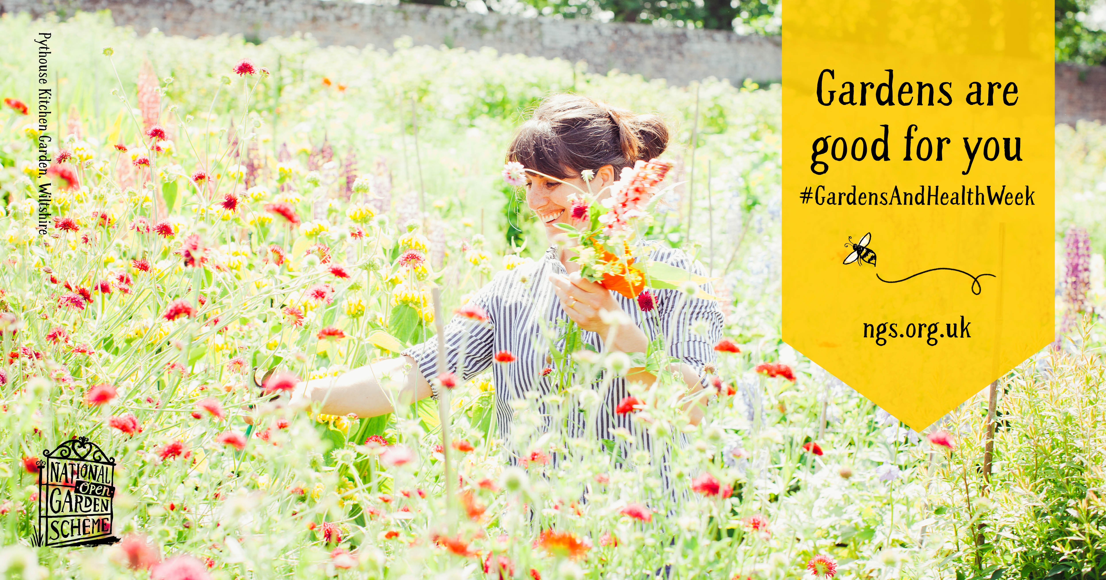

**GARDENS ARE GOOD FOR YOU**

The National Garden Scheme is marking its annual **Gardens and Health Week** in May with the launch of comprehensive proof that gardens are good for you. The charity’s fully interactive, digital booklet entitled **The Little Yellow Book of Gardens and Health** is packed with stories and case studies from garden owners, garden visitors and beneficiaries who have found solace and improved health and wellbeing by immersing themselves in nature. Alongside are views and expert tips on how to get the most from your garden experience, be it hands on or as a visitor.

In her foreword to the booklet National Garden Scheme Ambassador, Rachel de Thame says: “In a year like no other the confinement everyone had to endure, the anxiety and, in some cases, real tragedy has shown just how important gardens are to everyone’s physical health and mental wellbeing.

“The pandemic forced the gates to close on many gardens in 2020 and as a result the National Garden Scheme decided to capture this unique moment in time in a report: *Gardens and Coronavirus 2020 The importance of gardens and outdoor spaces during lockdown*. Over 2,400 people contributed and helped confirm something that we knew anecdotally; that the power of gardens to do good has never been more important. Now, this lovely *Little Yellow Book of Gardens and Health* showcases the wonderful work and gardens within the Scheme. Just reading it will lift your spirits. Visiting a garden will do even more.”

Other contributors include best-selling author of *The Well Gardened Mind* Sue Stuart-Smith, garden designer and National Garden Scheme Trustee Arit Anderson, garden journalist Ian Hodgson and occupational therapist Lisa Shyamalan.

“The booklet is designed to raise awareness of, and to celebrate, the myriad ways in which gardens are good for you and how the National Garden Scheme’s fundraising supports the nurturing benefits of gardens,” says National Garden Scheme Chief Executive, George Plumptre. “Whether you’re growing carrots in a window box or tending acres of herbaceous borders, recovering from a spinal injury, receiving treatment for cancer, grieving a loved one or simply coming out of lockdown in need of a lift you’ll find inspiration here.”

As more and more garden gates open to the public across the UK, what better way to celebrate than by recognising how central gardens, gardening and green spaces are to our health and wellbeing and treating yourself to a visit.

As spinal injury patient Curtis says in his story: “Outside is like medicine.”

Discover more in the *Little Yellow Book of Gardens and Health* here. <https://bit.ly/GardensAreGoodForYou>

**-Ends-**

**NOTES TO EDITORS:**

* All case studies and stories contained in the book can be reproduced as long as they are in the context of the National Garden Scheme and the *Little Yellow Book of Gardens and Health*
* You can download the header image [here](https://nationalgardenscheme.smugmug.com/Gardens-and-Health-2021-social-media-/n-d2knpr/) please credit Pythouse Kitchen Garden, Wiltshire which opens for the National Garden Scheme on September 9th.
* For additional, accompanying images please contact [Vicky@ngs.org.uk](mailto:Vicky@ngs.org.uk)
* For more on **Gardens and Health Week** see: [Gardens and Health - National Garden Scheme (ngs.org.uk)](https://ngs.org.uk/gardens-and-health-week/)
* Campaign hashtag #GardensAndHealthWeek

**About the National Garden Scheme**

The National Garden Scheme was founded in 1927 by The Queen’s Nursing Institute to raise money for district nurses. Ever since then it has given annual donations to nursing and health charities totalling over £60 million. It gives visitors unique, affordable access to over 3,600 exceptional private gardens in England and Wales and raises impressive amounts through admission charges and the sale of tea and cake.

Thanks to the generosity of garden owners, volunteers and visitors we are now the most significant charitable funder of nursing in the UK. As well as the Queen’s Nursing Institute, our beneficiaries include Macmillan Cancer Support, Marie Curie, Hospice UK and Parkinson’s UK.

The National Garden Scheme doesn’t just open beautiful gardens for charity – we are passionate about the physical and mental health benefits of gardens too. We fund projects which promote gardens and gardening as therapy, and in 2016 commissioned The Kings Fund report [*Gardens and Health*](https://ngs.org.uk/wp-content/uploads/2019/06/Kings-Fund-Report-1.pdf)*.* Our [*Gardens and Coronavirus 2020: The importance of gardens and outdoor spaces during lockdown*](https://eur01.safelinks.protection.outlook.com/?url=https%3A%2F%2Fngs.org.uk%2Fnew-report-gardens-and-coronavirus-2020%2F&data=04%7C01%7Cgplumptre%40ngs.org.uk%7C31eee0f2573e407e0bb808d8a35d7625%7Cbe12e590cc5c453d972278ca578468a0%7C0%7C0%7C637438969096349197%7CUnknown%7CTWFpbGZsb3d8eyJWIjoiMC4wLjAwMDAiLCJQIjoiV2luMzIiLCJBTiI6Ik1haWwiLCJXVCI6Mn0%3D%7C1000&sdata=3AnWGSUNUgDeORTj4ROZsGnR6uDNcDYfQxXiOuThW2c%3D&reserved=0) report was published in September 2020.